Volume rendering

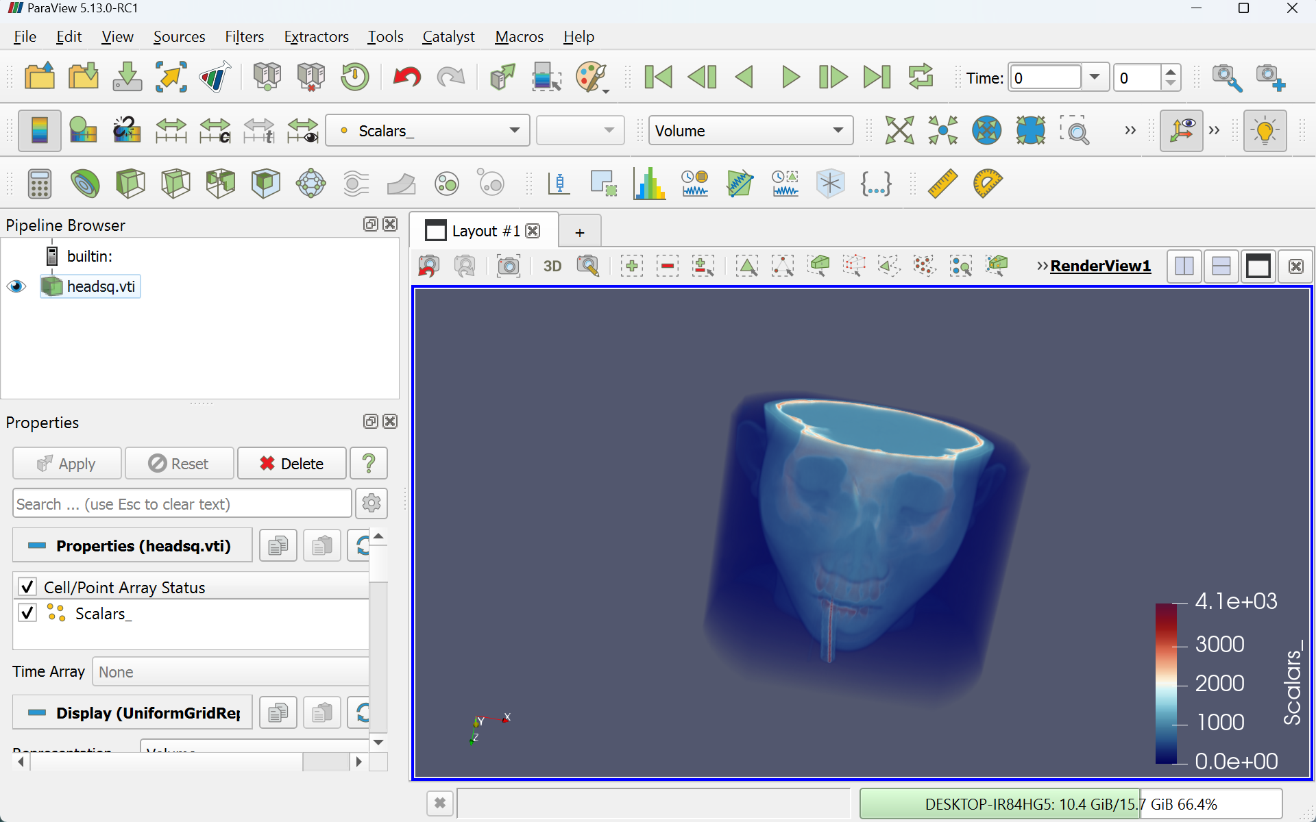

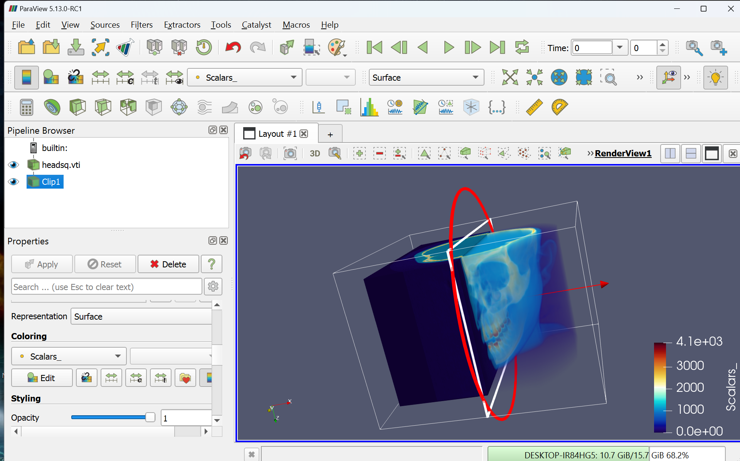Saggital slice

Coronal slice

Transverse Slice

